1. Create files file1 and file2 in directory dir1 and file3 in dir2.

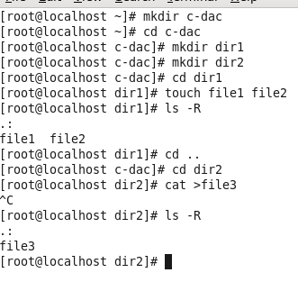

1. Concatenate the contents of file1 and file 2 into file3 residing in dir2.

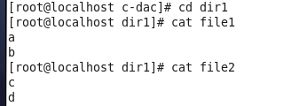

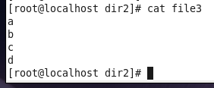

1. Move the file file1 and file2 to the directory where file3 resides.

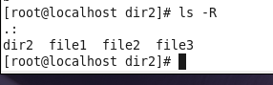

4. How will you list the current directory in columnar format?

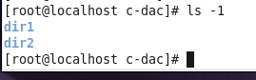

5.Remove a file and a director.

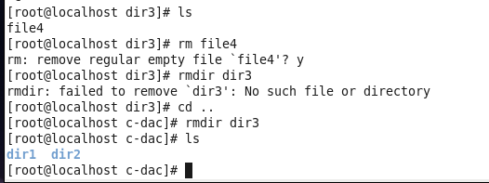

6. What is the use of ls -R?

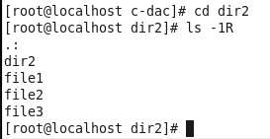

7. Display the list of files according to their modification time in a sorted way

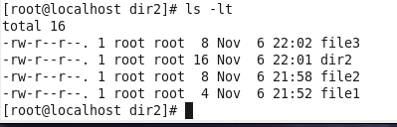

8. Display all information (date time of creation,owner of file,size)about the file in a directories.

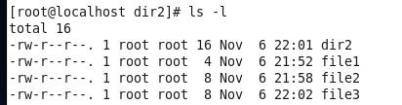

9. Rename a file name from oldname to a new name.

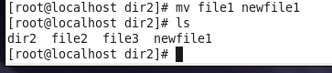

10. what is the use of cd command with the following options?

A: cd

B: cd..

C: cd /

D: cd &lt;directory&gt;









11. Display the present working directory.



12. create a file employee with following content

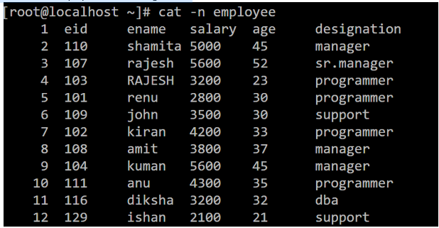

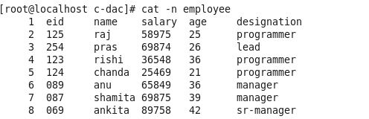

13. Print the first line of the file



14. Print 2 employees from the end of the file

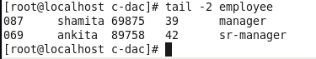

15. Print the details of the 3 rd employee to the next 5 employee

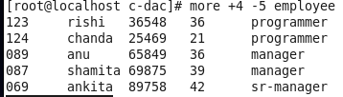

16. Print the ename and salary of each employee.

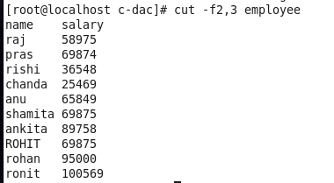

17. Print the name and salary of the last 3 employees

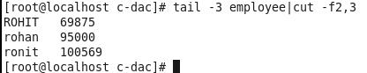

18. Print the eid,age and designation of the first 5 employees

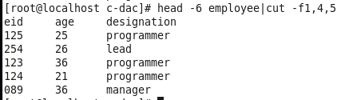

19. Print the name and salary of the last 3 employees

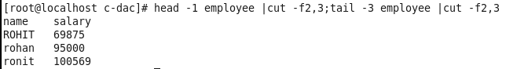

20. Print the name and salary of the last 3 employees in ascending order

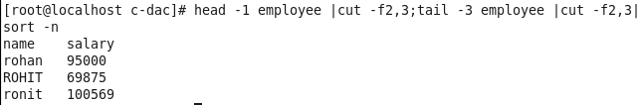

21. Print the eid,age and designation of the first 5 employees.



22. Print the detail of top 3 earners

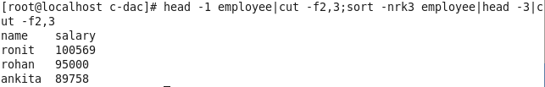

23. Print the detail of the lowest earners

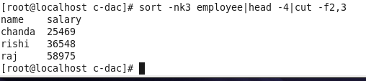

24. Display the salary in sorted order

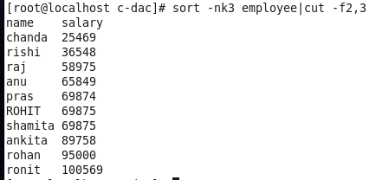

25. Display the name of employee in the sorted order of age.

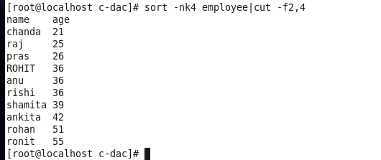

26. Display name of 2 youngest employee

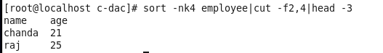

27. Print the unique designations

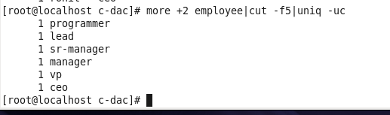

28. Print the employee name which are repeated (ignore case)



29. Print how many employees are there



30. Print name and salary and designation of employees who are working as programmer

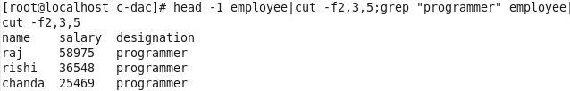

31. Print how many managers are there.

